Spring Garden Recipe – Elderflower ‘Champagne’
A lovely refreshing drink for summer and safe for children to drink
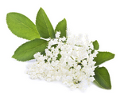

Ingredients:
7 Elderflower heads
4.5 litres of water
565gms sugar
Thinly sliced rinds and juice of 2 Lemons
2 Tablespoons of white vinegar
Equipment:
1 Large Container and Strainer/Sieve
3-4 Large Plastic Mineral Bottles ( glass can shatter from the fizz)
Method:
Boil the water and pour over the sugar.
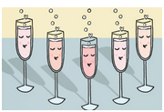
When cold put in the flowerheads, the rinds of lemons thinly sliced, lemon juice and vinegar. Cover with a clean tea towel and leave to stand for 24 hours. Strain and bottle. Cork well as this is very fizzy. Some people don’t tighten the caps too much for a couple of days and then tighten them as tightly as possible.
NB: It is important to pick the flowers early in the season.
If left until the end of flowering the ‘Champagne’ might not fizz.
And pick on a nice dry sunny morning.

Howth and Sutton Horticultural Society Ezine March 2018

