Summer Recipe – Raspberry Sorbet
(Serves 4)
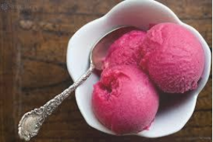
Ingredients:
400g Frozen Raspberries
80g Condensed Milk
Equipment:
Blender or Food Processor

Method:
Combine raspberries and condensed milk in a blender or food processor.
Freeze for about 4 hours. Should be soft enough to scoope.
Howth and Sutton Horticultural Society Ezine June 2018

