TEA BRACK - recipe from Helen Walsh
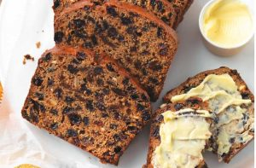

INGREDIENTS:
230mls/8fl oz Tea
170g/6oz Brown Sugar (alt use 75g if required less sweet)
450g/1lb Mixed Dried Fruits
1 Large Egg lightly beaten
250g/9oz Plain Flour
Half level tsp Bread soda
EQUIPMENT:
2lb Loaf Tin
Preheat oven 180c (adjust for fan) /Gas 4
METHOD
Soak sugar and dried fruit in tea overnight
Next day add lightly beaten egg to soaked mixture
Sieve flour and bread soda together and fold into mixture
Line Loaf tin and spoon mixture into tin
Cook in preheated oven for 90mins.
(Test after 75mins and cover with brown paper if getting too brown on top)
Skewer will come to clean if cooked.
Cool on a wire tray
Serve with butter and a nice cup of tea and ENJOY!

